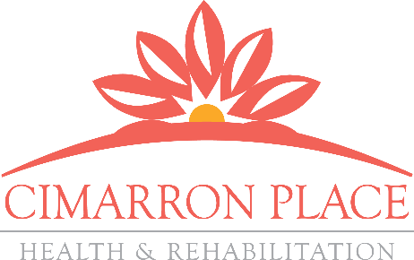
OUTCOMES MATTER

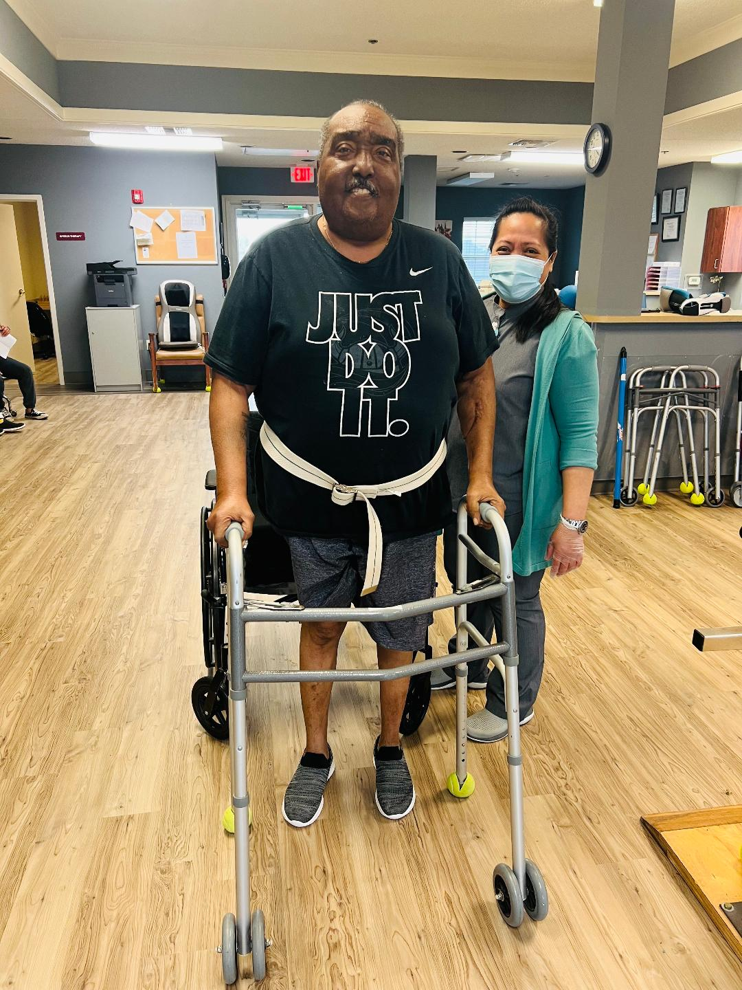
Amos Griffin is a 68-year-old male who was admitted to Cimarron Place on 1/22/2024 and discharged back home on 3/1/24. He was hospitalized due to shortness of breath related to Pulmonary Fibrosis.

Physical therapy evaluated Mr. Griffin on 1/23/2024. On the first day of therapy, Mr. Griffin needed max assistance with all transfers and was only able to walk 10 feet at also max assist. His main goal was to be able to walk longer distances and to become independent with daily activities because it is important for him to return home with his wife. Mr. Griffin was evaluated by Occupational therapy also on 1/23/2024 and found that he required maximum assistance for bathing and mod assist for dressing.

Following a 39 day stay of skilled nursing and therapy services, Mr. Griffin made significant gains with physical therapy by achieving his goal of being able to complete all transfers and able to walk 150 feet at just stand by assist. He also made gains in Occupational therapy and now completes lower body dressing at contact guard assist and is now bathing at set-up assist.

With quality care and client centered focused goals, Mr. Griffin is a true testimonial story of the positive outcomes produced at Cimarron Place!

MDS Section GG Functional Scores
06 - Independent
Completes the activity by him/herself with no assistance from a helper
05- Setup or clean-up assistance
Helper sets up or cleans up; patient completes activity. Helper assists
only prior to or following the activity.
04 - Supervision or touching assistance
Helper provides verbal cues and/or touching/steadying and/or contact guard
assistance as patient completes activity. Assistance may be provided
throughout the activity or intermittently.
03 - Partial/moderate assistance
Helper does LESS THAN HALF the effort. Helper lifts, holds, or supports
trunk or limbs but provides less than half the effort.
02 - Substantial/maximal assistance
Helper does MORE THAN HALF the effort. Helper lifts or holds trunk
or limbs and provides more than half the effort.
01 - Dependent
Helper does ALL of the effort. Patient does none of the effort to
complete the activity. Or the assistance of 2 or more helpers is required
for the patient to complete the activity.

