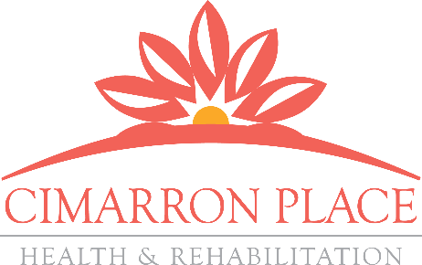
OUTCOMES MATTER

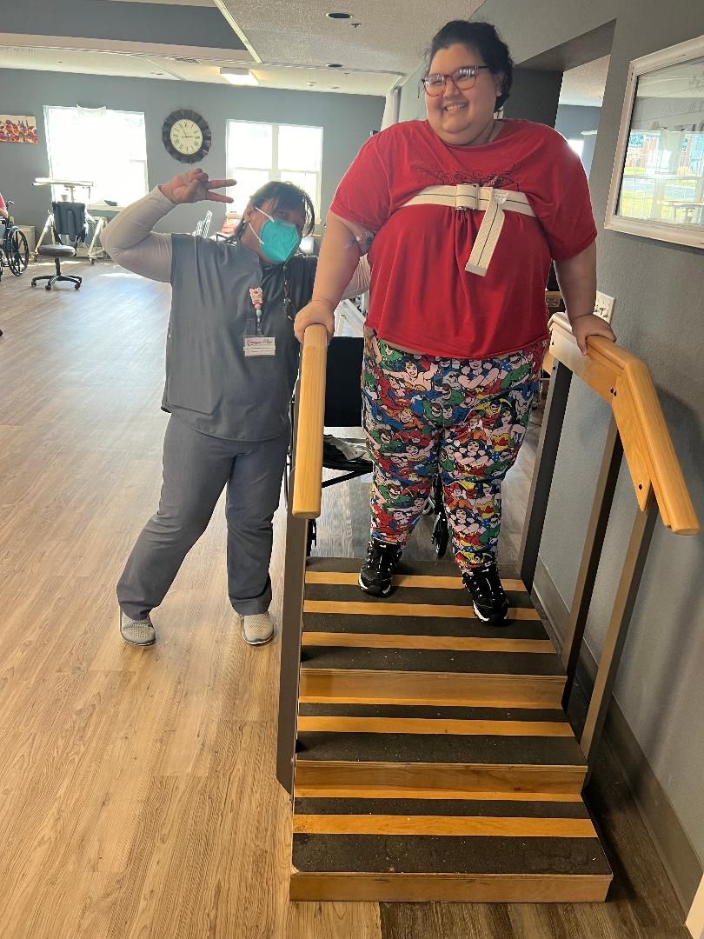
Mindy Huerta is a 33-year-old female who was admitted to Cimarron Place on 11/30/2023 and discharged 12/11/23 to hospital but returned on 12/18/23 and was able to discharge home on 1/14/24. She was hospitalized due to L4-L5 disc herniation with Cauda Equina, resulting in need for decompressive laminectomies. Ms. Huerta had lower extremity weakness with bladder incontinence, and wound vac at surgical incision sight with decreased independence.

Physical therapy evaluated Ms. Huerta on 12/01/2023. On the first day of therapy, she was unable to walk up steps and required minimal assist with transfers. Her main goal was to be more independent with walking up and down the stairs because it is important for her to return home on the second floor. Ms. Huerta was evaluated by Occupational therapy also on 12/01/2023 and found that she required maximum assistance for lower body dressing and for toileting.

Following a 37 day stay of skilled nursing and therapy services, Ms. Huerta made significant gains with physical therapy by achieving her goal of being able to walk up 15 steps and she can complete all functional transfers at stand by assist. She also made gains in Occupational therapy and now completes lower body dressing at minimal assist and toileting at contact guard assist.

With quality care and client centered focused goals, Ms. Huerta is a true testimonial story of the positive outcomes produced at Cimarron Place!

MDS Section GG Functional Scores
06 - Independent
Completes the activity by him/herself with no assistance from a helper
05- Setup or clean-up assistance
Helper sets up or cleans up; patient completes activity. Helper assists
only prior to or following the activity.
04 - Supervision or touching assistance
Helper provides verbal cues and/or touching/steadying and/or contact guard
assistance as patient completes activity. Assistance may be provided
throughout the activity or intermittently.
03 - Partial/moderate assistance
Helper does LESS THAN HALF the effort. Helper lifts, holds, or supports
trunk or limbs but provides less than half the effort.
02 - Substantial/maximal assistance
Helper does MORE THAN HALF the effort. Helper lifts or holds trunk
or limbs and provides more than half the effort.
01 - Dependent
Helper does ALL of the effort. Patient does none of the effort to
complete the activity. Or the assistance of 2 or more helpers is required
for the patient to complete the activity.

