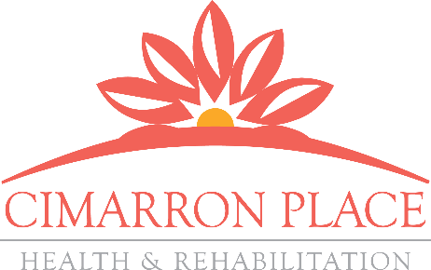
OUTCOMES MATTER

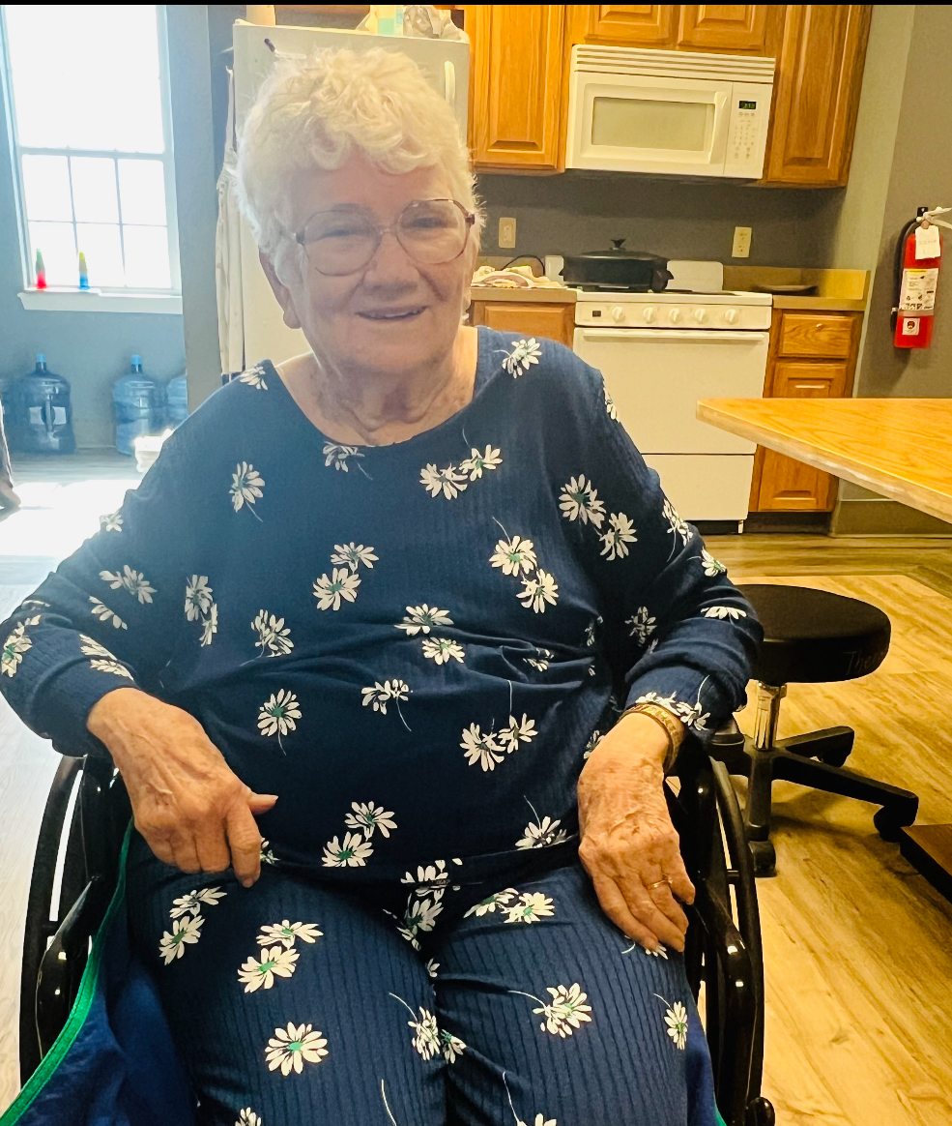
Rayma Hesseltine is a 86-year-old female who was admitted to Cimarron Place on 2/27/2024 and discharged 3/20/2024 back home. She was hospitalized due to a mechanical fall that resulted in a right femoral head fracture.

Physical therapy evaluated Ms. Hesseltine on 2/28/2024. On the first day of therapy, she was unable to take steps and required total assistance for transfers and bed mobility. Her main goal was to be more independent with self-care and ambulation. Ms. Hesseltine was evaluated by Occupational therapy also on 2/28/2024 and found that she required max assistance for lower body dressing and total assistance for toileting.

Following a 23 day stay of skilled nursing and therapy services, Ms. Baltazar made significant gains with physical therapy by achieving her goal of functional mobility with use of her rolling walker up to 40FT! She can complete transfers with minimal assistance. She also made gains in Occupational therapy and now completes lower body dressing and toileting with moderate assistance- which reduced caregiver burden.

With quality care and client-centered goals, Ms. Baltazar is a true testimonial story of the positive outcomes produced at Cimarron Place!

MDS Section GG Functional Scores
06 - Independent
Completes the activity by him/herself with no assistance from a helper
05- Setup or clean-up assistance
Helper sets up or cleans up; patient completes activity. Helper assists
only prior to or following the activity.
04 - Supervision or touching assistance
Helper provides verbal cues and/or touching/steadying and/or contact guard
assistance as patient completes activity. Assistance may be provided
throughout the activity or intermittently.
03 - Partial/moderate assistance
Helper does LESS THAN HALF the effort. Helper lifts, holds, or supports
trunk or limbs but provides less than half the effort.
02 - Substantial/maximal assistance
Helper does MORE THAN HALF the effort. Helper lifts or holds trunk
or limbs and provides more than half the effort.
01 - Dependent
Helper does ALL of the effort. Patient does none of the effort to
complete the activity. Or the assistance of 2 or more helpers is required
for the patient to complete the activity.

